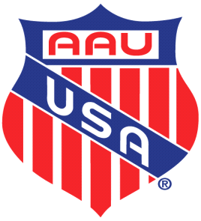
2025 ARKANSAS AAU TRACK SCHEDULE

May 3, 2025 – Cunningham Racing Track Club Meet – Jacksonville High School, Jacksonville, AR

May 10, 2025 – Twin City “Breeze” Track Club Meet – Liberty Eylau HS, Leopard Stadium, Texarkana, TX

May 17, 2025 – Port City S-P-E-E-D Track Club Meet –, Mills University High School, Little Rock, AR

May 24, 2025 – Team Elite Track Club Meet – Memorial Stadium, El Dorado, AR

May 31, 2025 – Christian Competition Track Club Meet – Forest Heights S.T.E.M. Academy, Scott Field, L.R., AR

June 13-14, 2025 – AAU District Qualifying Meet – Liberty Eylau HS, Leopard Stadium, Texarkana, TX

June 25-28, 2025 – Region 16 Multi Events & National Qualifying Meet – Springfield, MO

August 2-3, 2025 – AAU JO Multi Events, Humble, TX

August 4-August 9, 2025 – AAU JO Games, Humble, TX

