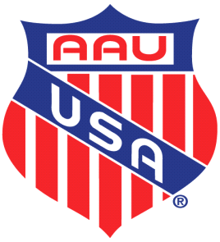
2024 ARKANSAS AAU TRACK SCHEDULE

May 4, 2024 – Twin City “Breeze” Track Club Meet – Liberty Eylau HS, Leopard Stadium, Texarkana, TX

May 11, 2024 – Port City S-P-E-E-D Track Club Meet –, TBD

May 18, 2024 – Cunningham Racing Track Club Meet – Jacksonville High School, Jacksonville, AR

May 25, 2024 – Christian Competition Track Club Meet – J.A. Fair Preparatory Academy, L.R., AR

June 1, 2024 – Team Elite Track Club Meet – Memorial Stadium, El Dorado, AR

June 7-8, 2024 – AAU District Qualifying Meet – Liberty Eylau HS, Leopard Stadium, Texarkana, TX

June 19-22, 2024 – Region 16 Multi Events & National Qualifying Meet – Bentonville West HS, Centerton, AR

July 26-28, 2024 – AAU JO Multi Events, North Carolina A&T, Greensboro, NC
July 28-August 3, 2024 – AAU JO Games, North Carolina A&T, Greensboro, NC

